**Evidence for Analysis and Design Unit.**

Your name here

Your Cohort

Date here

**AD - 1 Use case Diagram**

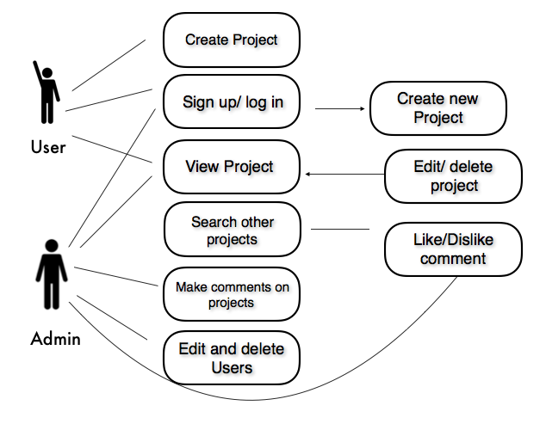

**AD - 2 Create a Class diagram using your Use case diagram.**

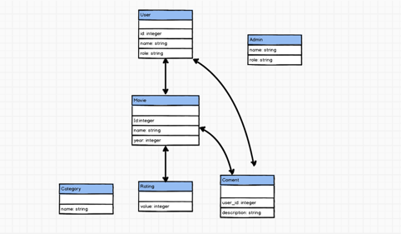

**AD - 3 Object diagram**

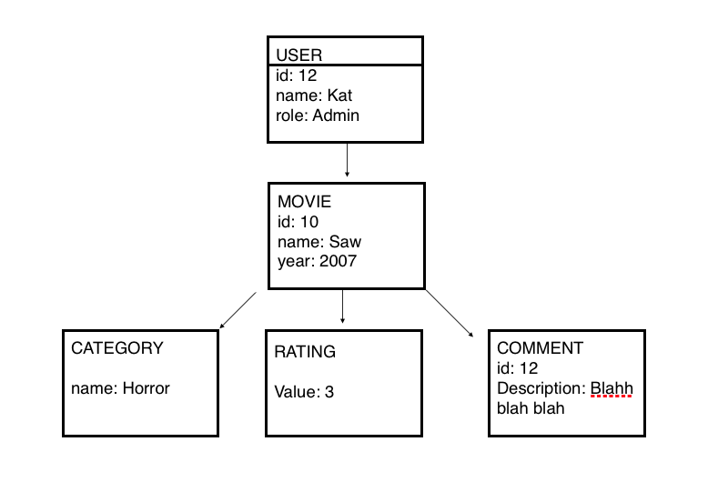

**AD - 4 Activity diagram**

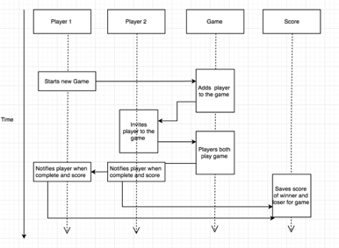

**AD - 5 Inheritance diagram**

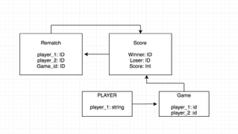

**AD - 6 Implementations Constraints**

|  |  |  |
| --- | --- | --- |
| **Constraints** | **Possible effect of constraint** | **Details** |
| **Hardware and software platforms** | **Will have to be run on Google Chrome as I used my own CSS style.** | **taking more time to implement the css depending on the browser used.** |
| **Performance requirements** | **As it has two players and no AI, we will need two machines to run the app in order to have two players play it.** | **No AI implemented because of time constraints.** |
| **Persistent storage and transactions** | **it will only save a possible 5 games at the time as there is not enough storage.** | **I would not change this as I want to keep it simple and not throw a lot of info to the player that is not important** |
| **Budgets** | **There was no budget used in this project** | **Personal project for the course of codeclan.** |
| **Time** | **We had a week to work on this project, time was short to add other features that I wanted to** | **I have decided to continue working on it at my own time. total of two weeks** |